**BANK LOAN REPORT QUERY DOCUMENT**

1. **BANK LOAN REPORT | SUMMARY**

**KPI’s:**

**Total Loan Applications**

SELECT COUNT(id) AS Total_Loan_Applications from bank_loan_data

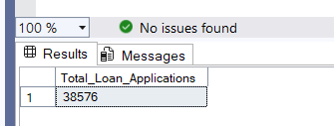

**MTD Loan Applications**

SELECT COUNT(id) AS MTD_Total_Loan_Applications from bank_loan_data

WHERE MONTH(issue_date)=12 AND YEAR(issue_date) = 2021

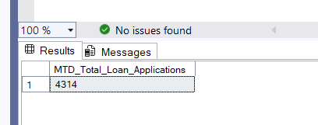

**PMTD Loan Applications**

SELECT COUNT(id) AS PMTD_Total_Loan_Applications from bank_loan_data

WHERE MONTH(issue_date)=11 AND YEAR(issue_date) = 2021

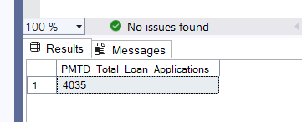

**Total Funded Amount**

SELECT SUM(loan_amount) AS Total_Funded_Amount FROM bank_loan_data

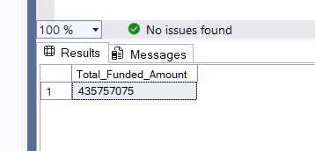

**MTD Total Funded Amount**

SELECT SUM(loan_amount) AS MTD_Total_Funded_Amount FROM bank_loan_data

WHERE MONTH(issue_date)=12 AND YEAR(issue_date)= 2021

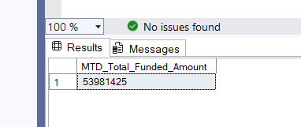

**PMTD Total Funded Amount**

SELECT SUM(loan_amount) AS PMTD_Total_Funded_Amount FROM bank_loan_data

WHERE MONTH(issue_date)=11 AND YEAR(issue_date)= 2021

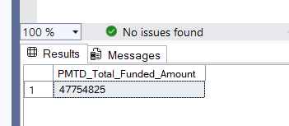

**Total Amount Received**

SELECT SUM(total_payment) AS Total_Amount_Received FROM bank_loan_data

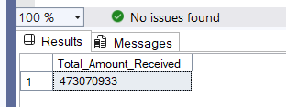

**MTD Total Amount Received**

SELECT SUM(total_payment) AS MTD_Total_Amount_Received FROM bank_loan_data

WHERE MONTH(issue_date)=12 AND YEAR(issue_date)=2021

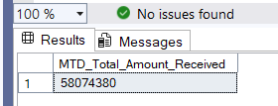

**PMTD Total Amount Received**

SELECT SUM(total_payment) AS PMTD_Total_Amount_Received FROM bank_loan_data

WHERE MONTH(issue_date)=11 AND YEAR(issue_date)=2021

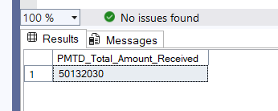

**Average Interest Rate**

SELECT AVG(int_rate)*100 AS Average_Interest_Rate FROM bank_loan_data

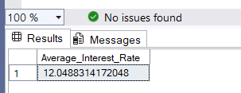

**MTD Average Interest**

SELECT AVG(int_rate)*100 AS MTD_Average_Interest_Rate FROM bank_loan_data

WHERE MONTH(issue_date)=12 AND YEAR(issue_date)=2021

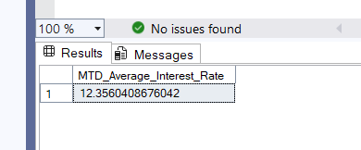

**PMTD Average Interest**

SELECT AVG(int_rate)*100 AS PMTD_Average_Interest_Rate FROM bank_loan_data

WHERE MONTH(issue_date)=11 AND YEAR(issue_date)=2021

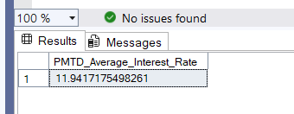

**Avg DTI**

SELECT AVG(dti)*100 AS Avg_DTI FROM bank_loan_data

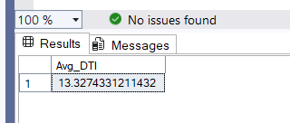

**MTD Avg DTI**

SELECT AVG(dti)*100 AS MTD_Avg_DTI FROM bank_loan_data

WHEREMONTH(issue_date)=12ANDYEAR(issue_date)=2021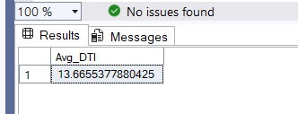

**PMTD Avg DTI**

SELECT AVG(dti)*100 AS PMTD_Avg_DTI FROM bank_loan_data

WHERE MONTH(issue_date)=11 AND YEAR(issue_date)=2021

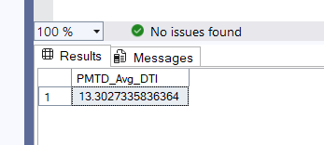

**GOOD LOAN ISSUED**

**Good Loan Percentage**

SELECT

(COUNT(CASE WHEN loan_status = 'Fully Paid' OR loan_status = 'Current' THEN id END)*100)

/

COUNT(id) AS Good_Loan_Percentage

from bank_loan_data

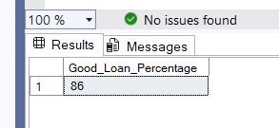

**Good Loan Applications**

SELECT COUNT(id) AS Good_Loan_Applications FROM bank_loan_data

WHERE loan_status = 'Fully Paid' OR loan_status = 'Current'

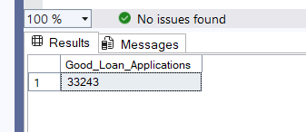

**Good Loan Funded Amount**

SELECT SUM(loan_amount) AS Good_Loan_Funded_Amount FROM bank_loan_data

WHERE loan_status = 'Fully Paid' OR loan_status = 'Current'

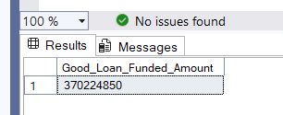

**Good Loan Amount Received**

SELECT SUM(total_payment) AS Good_Loan_Amount_Received FROM bank_loan_data

WHERE loan_status = 'Fully Paid' OR loan_status = 'Current'

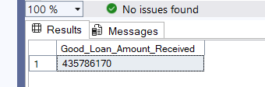

**BAD LOAN ISSUED**

**Bad Loan Percentage**

SELECT

(COUNT(CASE WHEN loan_status = 'Charged Off' THEN id END)*100.0)

/

COUNT(id) AS Bad_Loan_Percentage

from bank_loan_data

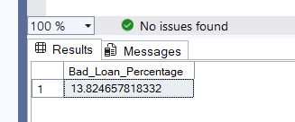

**Bad Loan Applications**

SELECT COUNT(id) AS Bad_Loan_Applications FROM bank_loan_data

WHERE loan_status = 'Charged Off'

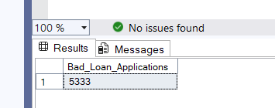

**Bad Loan Funded Amount**

SELECT SUM(loan_amount) AS Bad_Loan_Funded_Amount FROM bank_loan_data

WHERE loan_status = 'Charged Off'

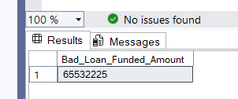

**Bad Loan Amount Received**

SELECT SUM(total_payment) AS Bad_Loan_Amount_Received FROM bank_loan_data

WHERE loan_status = 'Charged Off'

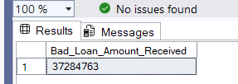

**LOAN STATUS**

SELECT

loan_status,

COUNT(id) AS Total_Loan_Applications,

SUM(total_payment) AS Total_Funded_Amount,

SUM(loan_amount) AS Total_Amount_Received,

AVG(int_rate*100) AS Average_Interest_Rate,

AVG(dti*100) AS DTI

FROM bank_loan_data

GROUP BY

loan_status

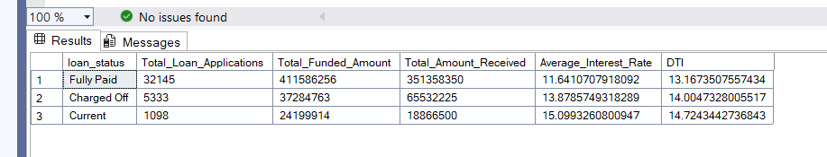

SELECT

loan_status,

SUM(total_payment) AS MTD_Total_Amount_Received,

SUM(loan_amount) AS MTD_Total_Amount_Funded

FROM bank_loan_data

WHERE MONTH(issue_date)=12

GROUP BY loan_status

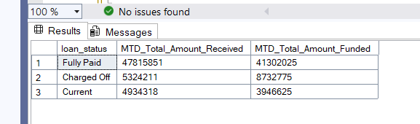

1. **BANK LOAN REPORT | OVERVIEW**

**MONTH**

SELECT

MONTH(issue_date) AS Month_Number,

DATENAME(MONTH,issue_date) AS Month_Name,

COUNT(id) AS Total_Loan_Applications,

SUM(loan_amount) AS Total_Funded_Amount,

SUM(total_payment) AS Total_Received_Amount

FROM bank_loan_data

GROUP BY MONTH(issue_date), DATENAME(MONTH,issue_date)

ORDER BY MONTH(issue_date)

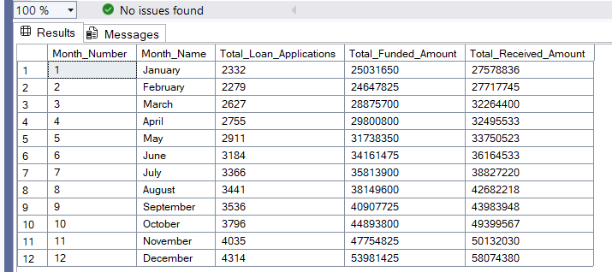

**STATE**

SELECT

address_state,

COUNT(id) AS Total_Loan_Applications,

SUM(loan_amount) AS Total_Funded_Amount,

SUM(total_payment) AS Total_Received_Amount

FROM bank_loan_data

GROUP BY address_state

ORDER BY address_state

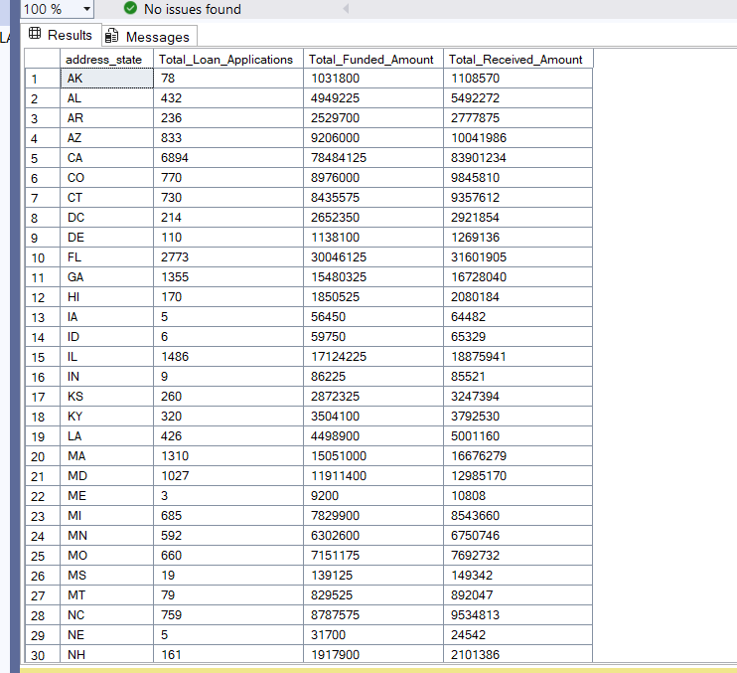

**TERM**

SELECT

term AS Term,

COUNT(id) AS Total_Loan_Applications,

SUM(loan_amount) AS Total_Funded_Amount,

SUM(total_payment) AS Total_Received_Amount

FROM bank_loan_data

GROUP BY term

ORDER BY term

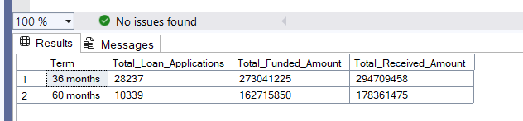

**EMPLOYEE LENGTH**

SELECT

emp_length AS Employee_Length,

COUNT(id) AS Total_Loan_Applications,

SUM(loan_amount) AS Total_Funded_Amount,

SUM(total_payment) AS Total_Received_Amount

FROM bank_loan_data

GROUP BY emp_length

ORDER BY emp_length

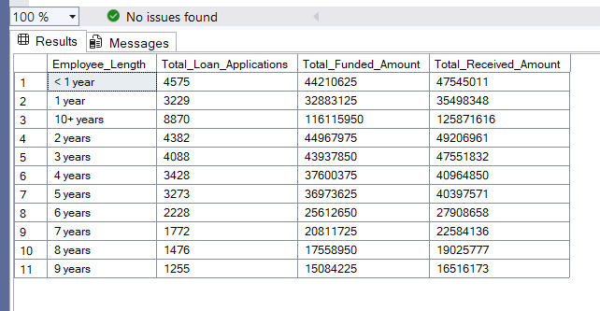

**PURPOSE**

SELECT

purpose AS PURPOSE,

COUNT(id) AS Total_Loan_Applications,

SUM(loan_amount) AS Total_Funded_Amount,

SUM(total_payment) AS Total_Received_Amount

FROM bank_loan_data

GROUP BY purpose

ORDER BY purpose

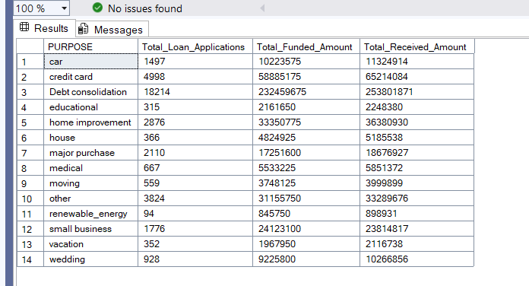\

**Home Ownership**

SELECT

home_ownership AS Home_Ownership,

COUNT(id) AS Total_Loan_Applications,

SUM(loan_amount) AS Total_Funded_Amount,

SUM(total_payment) AS Total_Received_Amount

FROM bank_loan_data

GROUP BY home_ownership

ORDER BY home_ownership

